Digital Design

CSCE 2114-L007

Blake Fasse

October 10, 2016

[bafasse@uark.edu](mailto:bafasse@uark.edu)

**Introduction**

The purpose of this lab was to write code in VHDL to display numbers 0-9 and letters A-F on the 7-segment display of the FPGA board. Each LED on the 7-segment display corresponds to a letter either A-G where a 0 turns the LED on and a 1 turns it off and the LEDS are programmed accordingly. For example, to display the letter A the code would be 0000001. VHDL code was given that displayed numbers 0-9 and the assignment was to write code to display letters A-F.

**Design**

The assignment says to open Quartus and to create a VHDL file and the copy the code that was given into the file. Once the file has been compiled and the FPGA has been programmed the code that was given displays numbers 0-9 depending on the whether any of the four switches on the board are a 0 or a 1. Since the code only allows 0-9 to be displayed on the FPGA board that means anything more than 1001 will display nothing. The goal is to take everything that would display nothing and to have it display letters A-F. The complete code that displays 0-9 and A-F is displayed below. 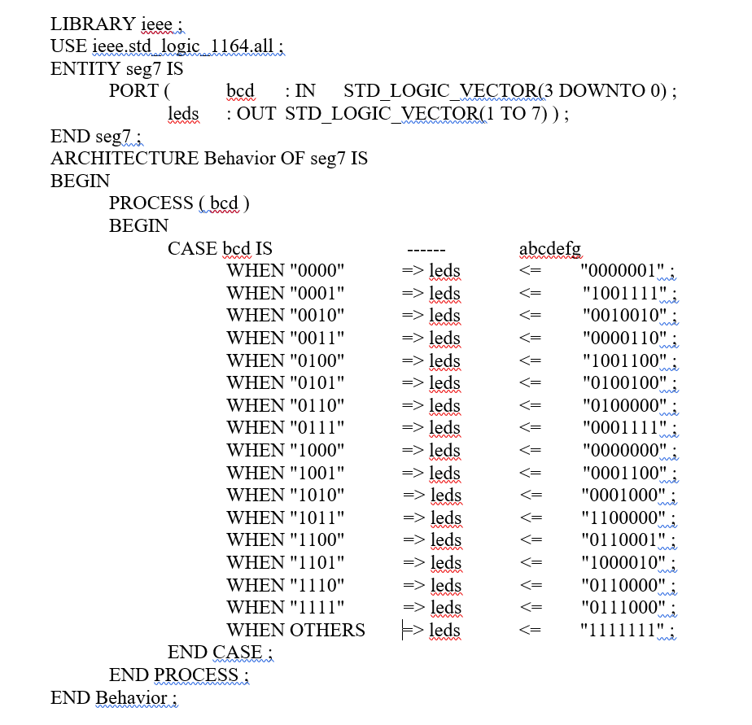

**Results**

The complete code that displays numbers 0-9 and letters A-F is displayed above. Before code was added to the program the FPGA would only display numbers 0-9 by changing four switches on the board in a fashion similar to binary to hexadecimal values. The only thing missing is the A-F letters, which was added in the lab. This lab took a little more time to complete then I’d like to admit. One thing that hindered progress was the mix-up in which value turned on the LED or even what the goal of the assignment was but once an understanding of what the goal of the lab was established it was able to be completed in no time.

**Conclusion**

This lab gave an introduction to writing in VHDL and how to output that code to the FPGA board. Using VHDL allowed to make a program that when you flipped switches on the FPGA board that a 7-segment display showed either numbers 0-9 or letters A-F and the switches represented binary code while the output matched hexadecimal values.